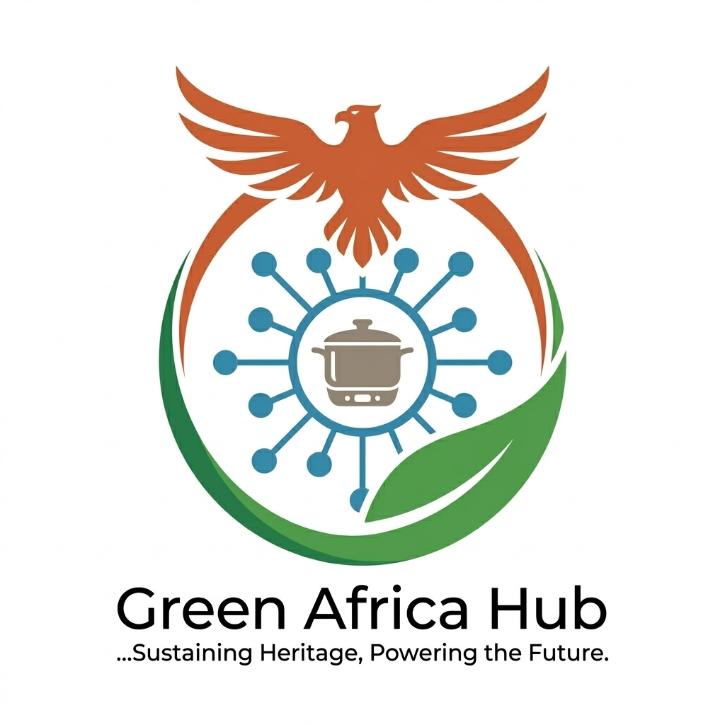 | GREEN AFRICA HUB LTD  Sustaining Heritage, Powering the Future  Company No. 17107299 | www.greenafricahub.org.uk | gracetuase@gmail.com | 07776 643169

Self-employed Learners: Progress Evidence Form
Future Leap / WECA Skills Bootcamp

Section 1: Your Details
Your Name: | Grace Omotuase
Date: | 26 March 2026
Section 2: New Work Contracts Secured or Significant Opportunities Being Developed
Description of the work / contract / opportunity
Following completion of the WECA Sustainability in Business Bootcamp delivered by Future Leap (March 2026), I have incorporated Green Africa Hub Ltd (Company No. 17107299, incorporated 21 March 2026) — a social enterprise addressing a critical gap in the UK sustainable food technology market. The business operates a Smart Kitchen Hub model for African and Caribbean communities in Bristol, combining energy-efficient induction cooking sessions, digital learning subscriptions, kitchen memberships, and B2B sustainability consulting. I have developed a proprietary Smart-Prep Methodology™ — a system that adapts traditional African and Caribbean recipes for energy-efficient induction cooking — alongside an AI carbon tracking dashboard built using Python, Scikit-learn, and Power BI. The business is now live with a professional website at www.greenafricahub.org.uk and is actively pursuing five revenue streams: in-person sessions (from £10/session), digital subscriptions (from £10/month), kitchen memberships (from £50/month), equipment commissions, and B2B consulting (from £500 per engagement). Financial projections forecast £28,200 revenue in Year 1, growing to £152,000 by Year 3.
How this work uses the skills developed in the Bootcamp
The WECA Sustainability in Business Bootcamp directly equipped me to develop and validate the carbon accounting framework underpinning Green Africa Hub's core proposition. The Bootcamp provided practical grounding in sustainability business models, net-zero strategies, and community-level carbon reduction — all of which I have applied directly in developing the Smart-Prep Methodology™ and AI carbon tracker. The business positioning, market analysis, and sustainability impact framework presented in our Innovator Founder Visa endorsement application and general business plan were substantially informed by skills, connections, and validation gained through the programme. The Future Leap partnership also provided the institutional backing referenced in our business plan and grant funding pipeline.
Date work was secured
21 March 2026 (company incorporation date)
Estimated value or duration
Year 1 revenue target: £28,200 | Year 3 revenue target: £152,000 | Grant pipeline: £125,000+ targeted from Innovate UK, UKSPF, WECA Green Economy Fund, and National Lottery
Section 3: Supporting Evidence
Supporting Evidence
Supporting evidence attached separately: Company incorporation certificate (Companies House, Company No. 17107299, incorporated 21 March 2026) and live business website: www.greenafricahub.org.uk
Section 4: Learner Declaration
I confirm that the information provided is accurate and that my participation in the Skills Bootcamp has supported my progression in securing new work opportunities.
Signature: | Grace Omotuase
Date: | 26 March 2026

